
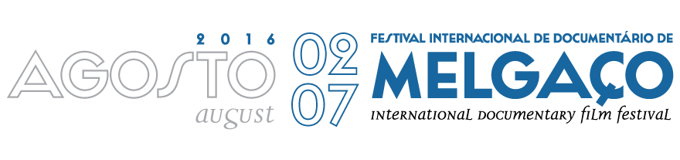
FORA DE CAMPO / OUTSIDE THE SCREEN
SUMMER COURES
3 to 7 of august 2016

CONSULT THE PROGRAM OF FORA DE CAMPO/ OUTSIDE THE SREEN, FILL IN THIS REGISTRATION FORM AND EMAIL IT TO DOCS@FILMESDOHOMEM.PT UNTIL 15TH OF JULY 2016.

REGISTRATION FORM
1º PARTICIPANT
NaME
DATE OF BIRTH
ADDRESS
POST CODE
(CELL)PHONE
E-MAIL
OCCUPATION
QUALIFICATIONS
BRIEFLY DESCRIBE YOUR INTERESTS (max 7 lines)
2º PARTICIPANT
NAME
DATE OF BIRTH
ADDRESS
POST CODE
(CELL)PHONE
E-MAIL
OCCUPATION
QUALIFICATIONS
BRIEFLY DESCRIBE YOUR INTERESTS (max 7 lines)
REGISTRATION MODALITY (PLEASE CHOOSE YOUR OPTION)
OPTION 1 – Participation in a limited number of activities of the summer Course.
OPTION 2 – Participation in all activities, without evaluation.
OPTION 3 – Participation in all activities, with evaluation.

In the last modality we recommend the following WORKING KIT: Laptop, photo or video Camera or Smartphone. It is suggested a video editing program, a sound editor (audacity) and freemind.
REGISTRATION MODALITY (PLEASE CHOOSE YOUR OPTION)
OPTION 1 - Participant – 50 €
OPTION 2 - Registration of participants from the Melgaço municipality – FREE
OPTION 3 - Registration with room and board / single room
(accommodation in a hotel and meals on the 3, 4, 5, 6 e 7) – 260 €
OPTION 4 (2 persons) - Registration with room and board/ double room
(accommodation in a hotel and meals on the 3, 4, 5, 6 e 7) – 390 €

The registration will only be valid after confirmation from the organizing committee.
If case of a paid registration you should, after confirmation, make your payment by bank transfer and email the respective payment receipt to docs@filmesdohomem.pt stating your full name.

The organizing committee will provide transportation by bus to all interested parts on the 03rd of August from Porto to Melgaço and return journey on the 08th August, with scheduling to be determined.

Please tick if agreed

PAYMENT INFORMATION:

Bank Transfer. Bank: Banco - Montepio
Internacional: IBAN : PT50 0036 0056 99100159898 33. Code SWIFT: MPIOPTPL

FOR FURTHER INFORMATION CONTACT
docs@filmesdohomem.pt
+351 962 834 852 (Rui Ramos)

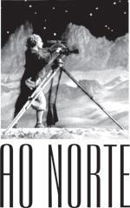 | 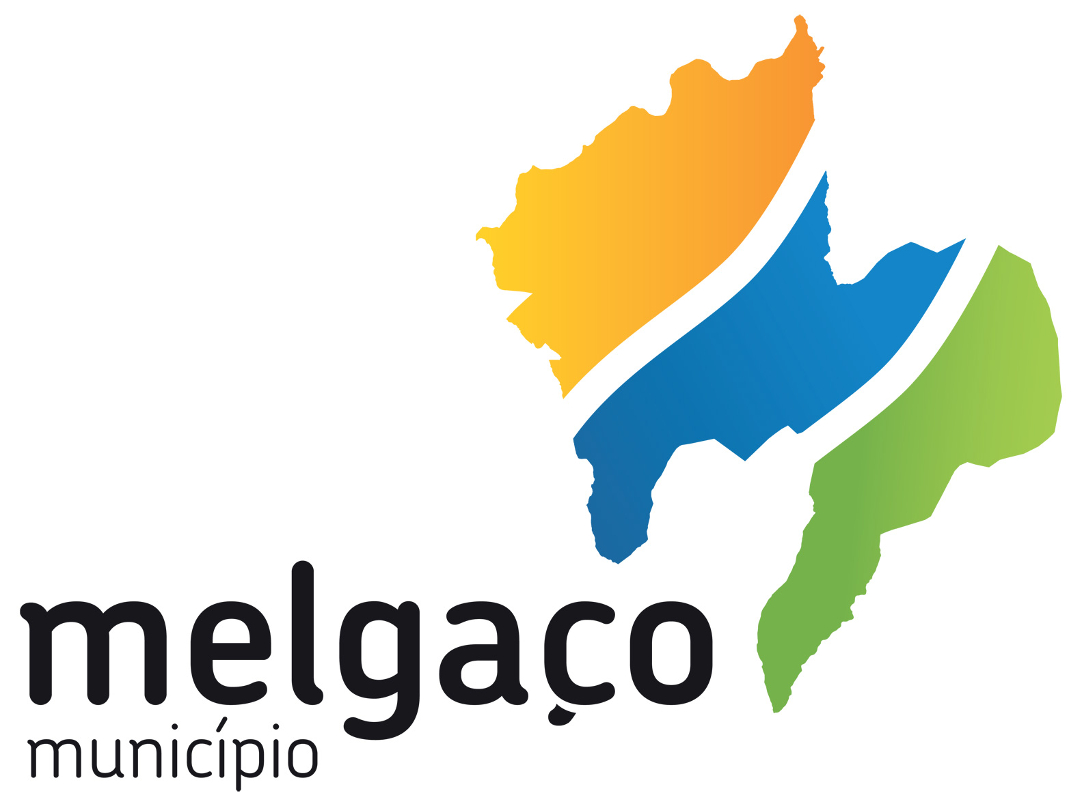
AO NORTE  ASSOCIAÇÃO DE PRODUÇÃO E ANIMAÇÃO AUDIOVISUAL  Praça D. Maria II, n.º113, R/C  4900-489 Viana do Castelo  Portugal  Tel.: +351 258 821 619  ao-norte@nortenet.pt  www.ao-norte.com | CÂMARA MUNICIPAL DE MELGAÇO  Largo Hermenegildo Solheiro  4960-551 Melgaço  Portugal  Tel.: +351 251 410 100  Fax: +351 251 402 429  geral@cm-melgaco.pt  www.cm-melgaco.pt

