CINEholidays
Registration until July 10th*

During four days (August 04 to 07), you’ll have access to:
- Space for a tent (4 nights), with electrical connection, at Melgaço Camping Site.
- Lunch and dinner with the Festival’s participants.
- Free Entry to all sessions of MDOC.

NAME: _________________________________________________________ Birth date____/____/______
Nationality _______________________________________________________________________________
Adress ___________________________________________________________________________________
Post Code ___________________ E-mail:____________________________________________________
Tel: _______________________________
School name:______________________________________ Attendance year:__________________________

Note – with this registration form you must send a document proving the course (a statement from the school or a photocopy of the student card) and proof of bank transfer, to:
ao-norte@nortenet.pt

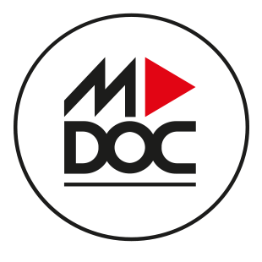

AO NORTE – ASSOCIAÇÃO DE PRODUÇÃO E ANIMAÇÃO AUDIOVISUAL
Praça D. Maria II, 113 R/C | 4900-489 VIANA DO CASTELO
tel: 258 821 619 | ao-norte@nortenet.pt | www.ao-norte.com

